**Ideation Phase**

**Brainstorm & Idea Prioritization Template**

|  |  |
| --- | --- |
| Date | 30 June 2025 |
| Team ID | LTVIP2025TMID30156 |
| Project Name | EDUCATIONAL ORGANISATION USING SERVICENOW |
| Maximum Marks | 4 Marks |

**Brainstorm & Idea Prioritization Template:** [Reference (click here)](https://app.mural.co/template/d3972cc7-355d-407c-9c3b-4e8aa673dbbb/91b6b97b-33ad-483e-b1d3-d931d043e470)

By implementing an automated student support ticketing system using ServiceNow, educational institutions can transform operational efficiency by centralizing and automating support requests, thereby enhancing student satisfaction and streamlining issue resolution, which can significantly improve the learning experience..

**Step-1: Team Gathering, Collaboration and Select the Problem Statement**

Problem Statement: How can our educational organization effectively use ServiceNow to improve student services and campus IT operations?

Team: IT admins, faculty representatives, student council, and operations manager collaborated to identify key challenges in service delivery.

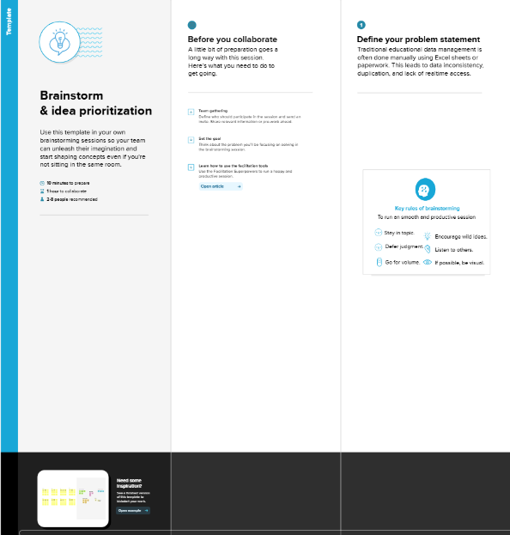

**Step-2: Brainstorm, Idea Listing and Grouping**

Ideas generated:

- Automate student help desk ticketing

- Set up a self-service knowledge portal

- Use ServiceNow to track IT assets in labs

- Enable faculty to raise IT and HR service requests

- Student mobile app integration with ServiceNow

Grouped into: Student Support, IT Operations, Faculty Services

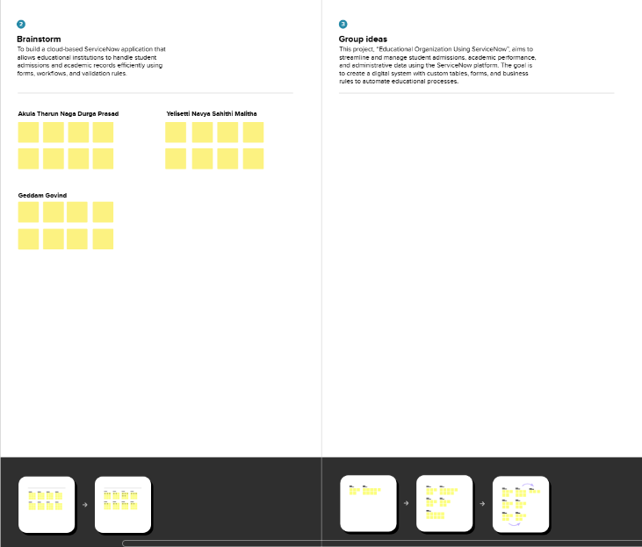

**Step-3: Idea Prioritization**

Top Prioritized Ideas:

1. Student Help Desk Automation

2. Self-service Knowledge Portal

3. IT Asset Management

Criteria considered: Impact on students, ease of implementation, long-term value

